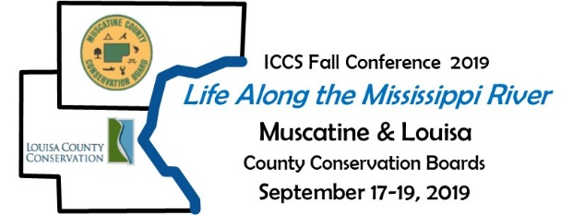

**2019 Annual Fall Conference**

**Iowa’s County Conservation Systems**

Exhibitor Request Form

Company Name: _________________________________ Date: __________________________

Address: _______________________________________ Phone: _________________________

Contact Person: __________________________________ Email: __________________________

Exhibitor Name: _________________________________ Email: _________________________­_

Products/Services: ____________________________________________________________________

SPONSORS: PLEASE MARK WHICH VENDOR TIMES YOU WOULD LIKE TO HAVE A BOOTH.

WE ARE GIVING FIRST PREFERENCE TO SPONSORS SINCE SPACE IS LIMITED.

**Tuesday, Sept. 17 from 5:30 – 7:00 pm – Fish Fry at the Riverview Center**

$200/vendor

*Setup between 3:30-5:00 pm. (6’ table and 2 chairs provided) – limited indoor spaces only

We plan to exhibit at the Riverview Center located at 215 Sycamore St., Muscatine, IA 52761

* Yes – includes 1 meal (you can order more meals on the back of this form).
* No – we do not plan to exhibit at the Fish Fry.

**Wednesday, Sept. 18 and Thursday, Sept. 19 from 7am – 9am – Breakfast at the Merrill Hotel**

10 available per day at $200/day

*10 spots available each morning* – reserved on a first come, first served basis – indoor space only!

Setup between 6-7am. (6’ table and 2 chairs provided)

We plan to exhibit at the Merrill Hotel during the breakfast on:

* Wednesday, Sept. 18 – includes 1 meal
* Thursday, Sept. 19 – includes 1 meal
* We do not plan to exhibit at the Merrill Hotel

**Wednesday, Sept 18 - Celebration Belle Riverboat Cruise on the Mississippi River**

No exhibit space is available, but vendors are invited to attend and visit with participants.

** Note – a limited number of tickets are available for the Riverboat but are included with sponsorship levels of $1,000 and up.

* We would like to reserve space on the Riverboat.

**Wednesday, Sept. 18 from 4:30 – 7:30 pm – BBQ at the Bayer Rec Building**

$200/vendor – Indoor & outdoor space available!

*Setup between 2:30 – 4:30. (6’ table and 2 chairs provided)

We plan to exhibit at the Bayer Rec Building – includes 1 meal

* Yes – we would like indoor space
* Yes – we would like outdoor space. Would you like a table? 🞎 yes 🞎no
* We do not plan to exhibit at the Bayer Rec Building.

PLEASE FILL OUT THE FOLLOWING TO REQUEST EXHIBITOR SPACE:

**Registration fees: **$50 Preferred Member Discount**

**Vendor Fees (includes 1 meal/vendor time):** Optional Additional Meals:

Tuesday Fish Fry Vendor ($200): _________ Additional Fish Fry ($15 each): __________

Wednesday Breakfast ($200): _________ Additional Breakfast ($20 each): __________

Wednesday BBQ ($200): _________ Additional BBQ ($20 each): __________

Thursday Breakfast ($200): _________ Additional Breakfast ($20 each): __________

Celebration Belle Riverboat Tour (includes lunch buffet) # of people __________ X $125: __________

🞎 I am a preferred vendor – if you are, you can deduct $50 from your total.

Total fees to be billed: $ ______________

**Here is the sponsorship info in case you want to sponsor instead…**



🞎 I/We would like to be a sponsor for this year’s ICCS Conference in the amount of: _______________

**If you sponsor, please still use the form above to let us know when you would like to exhibit and if you require any additional meals/boat rides**

*Checks should be made out to Iowa County Conservation System (ICCS)

Please return this form ASAP to reserve space(s). Filled on first-come, first-served basis. Deadline to reserve space is: August 15, 2019.

**Note the fish fry and breakfasts have a limited number of exhibitor space, conference sponsors will have first choice.**

**Sponsors: please make checks payable to:** Tri-Rivers Conservation Foundation & mail to: 12635 County Road G56, Suite 106, Wapello, IA 52653.

**Exhibitors: please wait for a bill to pay so we can make sure you are able to get the space you request.**

Mail this form back to: Muscatine County Conservation Board, 3300 Cedar St., P.O. Box 109, Muscatine, IA 52761 or email to: conservation@co.muscatine.ia.us.